ECONÓMICAS
Surname, Surname, Surname, Surname and Surname / Economic CUC, vol. X no. X, pp. (Postprint version), XXX | CUC
It should be explanatory, between 12 to 15 words, aligned to the left  Debe ser explicativo, con entre 12 y 15 palabras, alineado a la izquierda | 

DOI: https://doi.org/10.17981/xxx
Article from Choose an item.
Date of receipt: XXX
Return date: XXX
Date of acceptance: XXX
Publication date: XXX

Names and surnames
ORCID
Institutional Affiliation
City, Department (Country)
Email

Names and surnames
ORCID
Institutional Affiliation
City, Department (Country)
Email

Names and surnames
ORCID
Institutional Affiliation
City, Department (Country)
Email

To cite this article:

Last Name, N., Last Name, N., Last Name, N., Last Name, N. & Last Name, N. (20xx). Title of the work. Económicas CUC, XX(X). DOI: XXX

JEL: Add classification.

Adstract
Elaborate synthesis of the work in no more than 300 words that includes: Introduction, Objective, Design / methodology, Results / findings, Limitations / implications, Originality / value and Conclusions. Use FONT Century Schoolbook and adjust its size if necessary.
Keywords: Between 5 and 7. It must be remembered that they are the main descriptors of the research, the words of the title should not be repeated, these should increase the search rank and findings.

Resumen
Preparar una síntesis del trabajo en no más de 300 palabras que incluya: Introducción, Objetivo, Diseño / metodología, Resultados / hallazgos, Limitaciones / implicaciones, Originalidad / valor y Conclusiones. Utilice TYPE Century Schoolbook y ajuste su tamaño si es necesario
Palabras clave: Entre 5 y 7. Tenga en cuenta que estos son los principales descriptores del estudio, las palabras del título no deben repetirse, deben aumentar el rango de búsqueda y los hallazgos.

INTRODUCTION

Answer the why? And for what? The research has been done, exposes the interest in the scientific context, must include previous work and what aspects do not make clear, this is the object of your research. The last paragraph of the introduction is usually used to summarize your study objective and method used.
Times New Roman, font size 14. Right indent of 0.5 cm. Single line spacing and subsequent spacing between 12-point paragraphs.
STATE OF THE ART
Show the current theoretical status of the researched topic, evolution and latest findings of the topic. Recommended
Times New Roman, font size 14. Right indent of 0.5 cm. Single line spacing and subsequent spacing between 12-point paragraphs.
Subtitle level 1
Times New Roman, font size 14. Right indent of 0.5 cm. Single line spacing and subsequent spacing between 12-point paragraphs.
Subtitle level 2
Times New Roman, font size 14. Right indent of 0.5 cm. Single line spacing and subsequent spacing between 12-point paragraphs.
Subtitle level 3
Times New Roman, font size 14. Right indent of 0.5 cm. Single line spacing and subsequent spacing between 12-point paragraphs.
METHODOLOGY
It must be based on the research method selected for the development of the work.
Times New Roman, font size 14. Right indent of 0.5 cm. Single line spacing and subsequent spacing between 12-point paragraphs.
Subtitle level 1
Times New Roman, font size 14. Right indent of 0.5 cm. Single line spacing and subsequent spacing between 12-point paragraphs.
Subtitle level 2
Times New Roman, font size 14. Right indent of 0.5 cm. Single line spacing and subsequent spacing between 12-point paragraphs.
Subtitle level 3
Times New Roman, font size 14. Right indent of 0.5 cm. Single line spacing and subsequent spacing between 12-point paragraphs.
RESULTS
It expresses the results of the experiments and/or analyses described in the Material and Methods and presents the evidence supporting these results.
Times New Roman, font size 14. Right indent of 0.5 cm. Single line spacing and subsequent spacing between 12-point paragraphs.
Subtitle level 1
Times New Roman, font size 14. Right indent of 0.5 cm. Single line spacing and subsequent spacing between 12-point paragraphs.
Subtitle level 2
Times New Roman, font size 14. Right indent of 0.5 cm. Single line spacing and subsequent spacing between 12-point paragraphs.
Subtitle level 3
Times New Roman, font size 14. Right indent of 0.5 cm. Single line spacing and subsequent spacing between 12-point paragraphs.
DISCUSSION OF THE RESULTS
Discussion of the results: Start the discussion with the answer to the question of the introduction, relying on the evidence presented in the results obtained. Include the recommendations you think are appropriate.
Times New Roman, font size 14. Right indent of 0.5 cm. Single line spacing and subsequent spacing between 12-point paragraphs.
Subtitle level 1
Times New Roman, font size 14. Right indent of 0.5 cm. Single line spacing and subsequent spacing between 12-point paragraphs.
Subtitle level 2
Times New Roman, font size 14. Right indent of 0.5 cm. Single line spacing and subsequent spacing between 12-point paragraphs.
Subtitle level 3
Times New Roman, font size 14. Right indent of 0.5 cm. Single line spacing and subsequent spacing between 12-point paragraphs.
CONCLUSIONS
Close the paper with a logical reasoning validated by your findings, remember it is not a suggestion, nor a summary of the above. It must respond to the proposed objective.
Times New Roman, font size 14. Right indent of 0.5 cm. Single line spacing and subsequent spacing between 12-point paragraphs.
REFERENCES
Please note that:
- It will cite and reference the same authors.
- The citation and referencing must be done according to the regulations of the magazine Económicas CUC available in https://revistascientificas.cuc.edu.co/economicascuc/editoriales
- There is a minimum of references according to the type of article submitted for evaluation, these are described and defined in https://revistascientificas.cuc.edu.co/economicascuc/editoriales
- If the reference is electronic, the DOI must be mentioned or, failing that, the URL that leads directly to the document.
Times New Roman, font size 14. French indentation of 1 cm. Single line spacing and subsequent spacing between 12-point paragraphs.
Example:
Buitrago, S., Duque, P., & Robledo, S. (2020). Corporate Branding: a literature review. Economic CUC, 41(1). https://doi.org/10.17981/econcuc.41.1.2020.Org.1
BIODATA
Names and Surnames Give a brief sketch about you Degrees and universities where they were obtained. Positions held and institutional affiliation. Outstanding recognitions. Research interests. ORCID: https://orcid.org/xxx-xxxx-xxxx-xxxx
Names and Surnames Give a brief sketch about you Degrees and universities where they were obtained. Positions held and institutional affiliation. Outstanding recognitions. Research interests. ORCID: https://orcid.org/xxx-xxxx-xxxx-xxxx
Names and Surnames Give a brief sketch about you Degrees and universities where they were obtained. Positions held and institutional affiliation. Outstanding recognitions. Research interests. ORCID: https://orcid.org/xxx-xxxx-xxxx-xxxx

How are the tables and tables presented?
For the presentation of the tables and tables you can have colors if you wish. They are written in time New Roman, number 12, single-spaced. (See example table 1)
Table 1:
Search criteria and results
Database | Search equation | Results | Total Items
Scopus | THEME:  "internationalization*" AND "latin*" AND  ("enterprise*" OR "business*")  Time period: 2000-2020 | 131 | 225
Web of Science |  | 94 | 225
Source: authors.

How are graphs, figures, photos, images, others presented?
For the presentation of graphs, figures and images you can have colors if you wish. (See example figure 1)

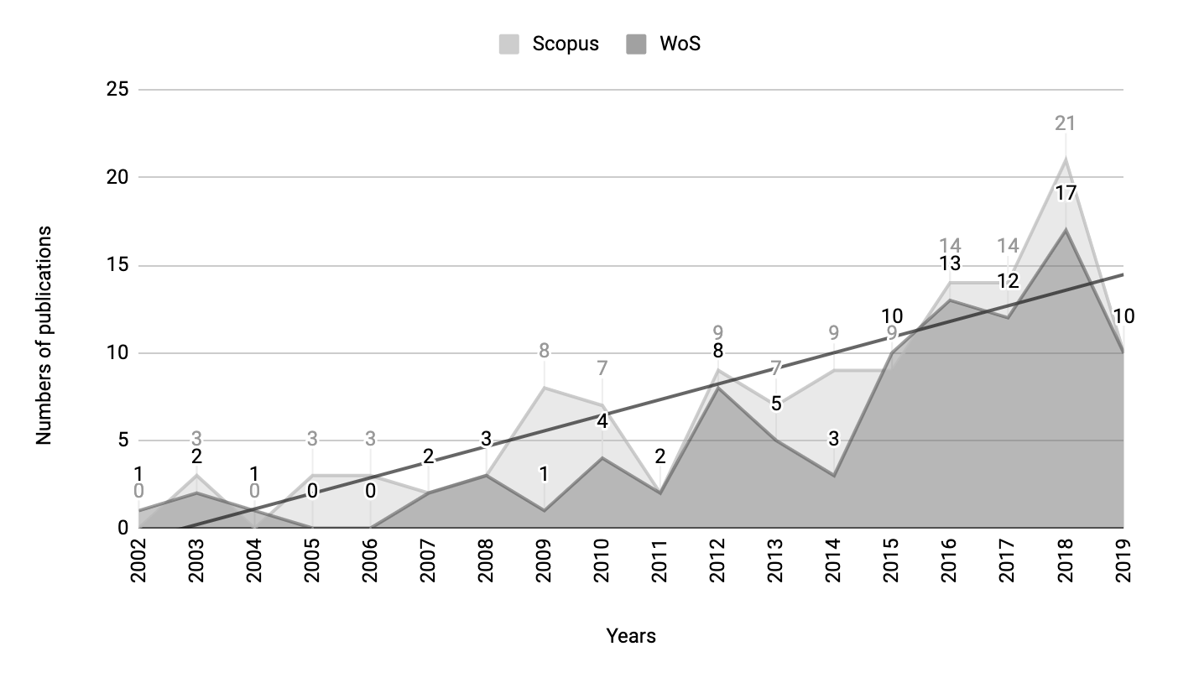
Figure 1. Annual scientific production
Source: authors.

The aforementioned resources should be included where needed in the body of work.

