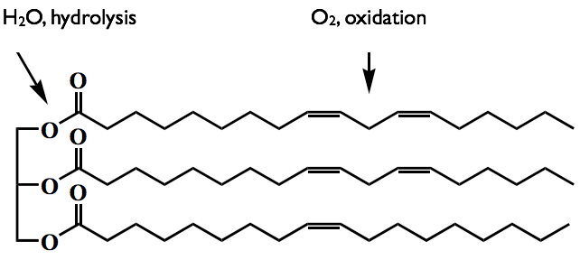
Figure 1. Natural ester fluids molecular structure. Indicates the atoms which can carry out oxidation and hydrolysis reactions.

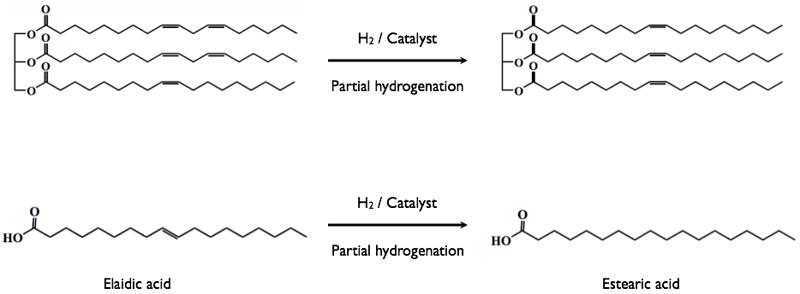
Figure 2. Hydrogenation reaction of fatty acids and esters. Metal-based catalysts accelerate the partial hydrogenation.

